The Atlantic World: Europeans Settle the Americas (Chapter 20.1, 20.2)
Objectives:
1. We will be able to describe the factors that led to continued settlement by Spain and other European powers.
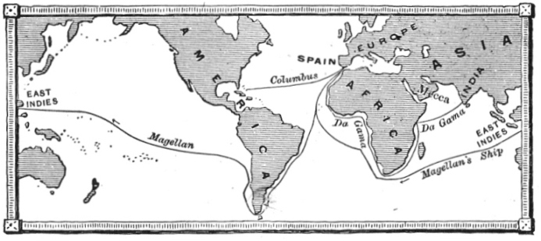
2. We will be able to explain different views about acquisition of land by European powers and what areas different nations controlled.
3. We will be able to analyze contrasting view on human rights.

Spain Builds and American Empire
- Voyages of Columbus-(1492-1503)
  - Most interested in ____________ and ________________
    - Continues to take control of lands in the _______________________________-trying to reach the Indies
      - Spanish intend to make these lands colonies (____________________________ __________________________)
- Another Major Explorer
  - _______________________________________ to Voyage Pacific (1519-1522)-Dies on Voyage
    - Funded by Spain
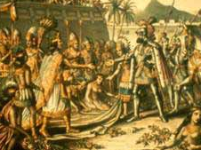
  - First successful circumnavigation of the world (ie. around the globe)
Spanish Conquest the Americas
- _____________________________________ (1519)
  - Lands in Mexico to claim lands for Spain (needs _________ and ____________)
    - Uses _________________________ (conquerors to help)
  - Cortes conquerors the Aztecs
    - Spanish do so by superior weapons, help from native groups and _________________________
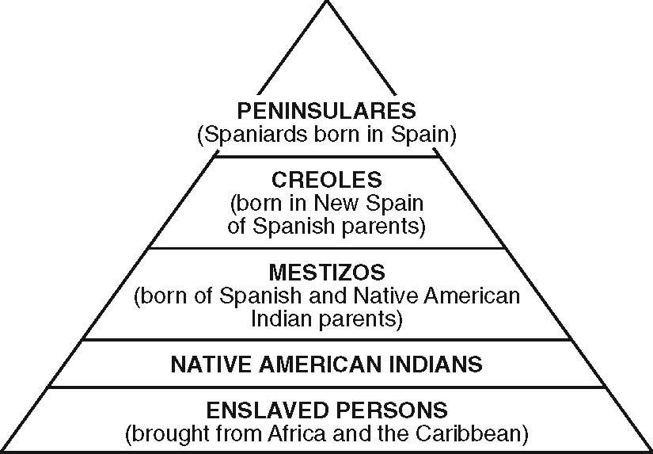
- Francisco Pizarro (1532)
  - Subdues the Incas and leader Atahualpa
    - Demonstrates Spain's use of conquest to build its empire
  - Spain has an empire New Spain (Mexico, Central America), South America, and Caribbean
- IMPACTS:
  - Hierarchical Way of Life
  - ___________________________-System which natives labored for Spanish landlords (mines, farmed, ranched)and in return supposed to be treated fairly (but did not happen)
    - VERY BRUTAL SYSTEM
  - Spain becomes a MAJOR power because newfound wealth (particularly silver!!!!!!!)
    - Allows for golden age in art and culture in Spain but also increased military might and expansion to the north
  - Other European powers come to challenge!
- Portugal does well in Brazil, particularly with sugar
Europeans Settle North America
- France
  - France arrives in current Canada and creates __________________---Fur trade and did not settle heavily
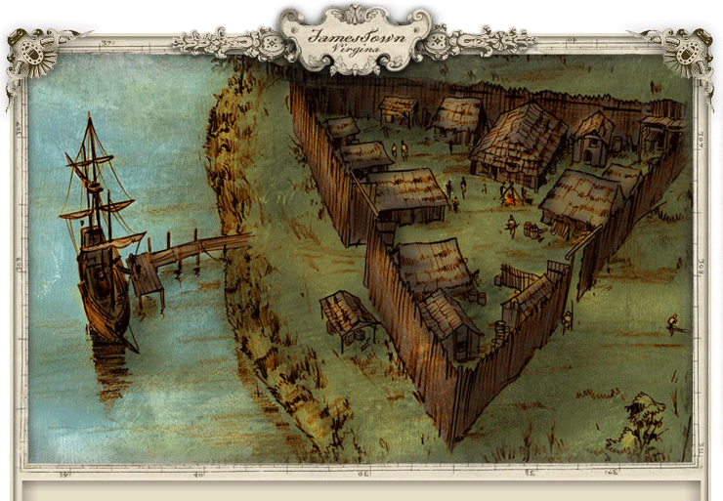
- England-Settles
  - 1607-Settle Jamestown in modern Virginia
    - England's first permanent settlement and discovered tobacco
  - ___________________ and ______________ settle for religious freedoms
- The Dutch
  - Henry Hudson (1609, 1610) navigates for a Northwest route to Asia
    - Does not work but leads to _____________ _______ _____________ (around current New York)
- France (Haiti) and England (Jamaica) do have areas in the Caribbean with Spain
New World Conflicts
- English oust the Dutch (1644) and eventually create their ______________________ (what do these become?__________________________________________)
- English oust the French in the ___________________________________________________-Take over eastern half of North America (Part of a global conflict called the Seven Years’ War.)
- Series of strained relationships with natives and diseases (Smallpox, measles, mumps, typhus)!

What does this chart say about the Spanish's impact on Central America?

Settlement of the Americas Maps
Spanish Empire 1754 Spanish Empire 1763 Portugal 1700s
