Roman Republic Guided Notes
Roman Geography
- In addition to Greece, a significant classical civilization was ancient _______________________.
  - Rome was located on the ___________________ peninsula along the Mediterranean Sea
  - The Romans were influenced by the _______________________ & neighboring Etruscans
Culture of Ancient Rome
- Roman religion was polytheistic & based on the ______________________ gods (usually only the names changed)
- __________________________ writing was called Latin & was based on Greek writing
- Roman _______________________________ borrowed heavily from Greek styles
  - Like Greek ____________________________, Roman cities had a forum for markets & public gatherings
- Society was divided among 3 major groups:
  - At the top were the nobles, called _____________________________, who controlled most of the land & held key military & gov’t positions (made up 5% of Roman citizens)
  - Most people were commoners, called __________________________, who were farmers, shopkeepers, or peasants; Plebeians paid the majority of taxes (made up 95% of Roman citizens)
  - At the bottom of society were _______________________ & other non-Roman citizens
Government of Ancient Rome
- Rome was originally ruled by kings, but in 509 B.C. the Romans created a ___________________
  - A republic is a form of government in which citizens have the power to _____________________________________ their leaders
    - The most important feature of the republic was the ______________________________, whose 300 members were elected by citizens to make laws & taxes
- In 451 B.C., government officials wrote down Rome’s laws onto the ____________________________________ which were hung in the forum for all citizens to see
  - The Twelve Tables were based on the idea that all citizens had a right to the ____________________________________________________
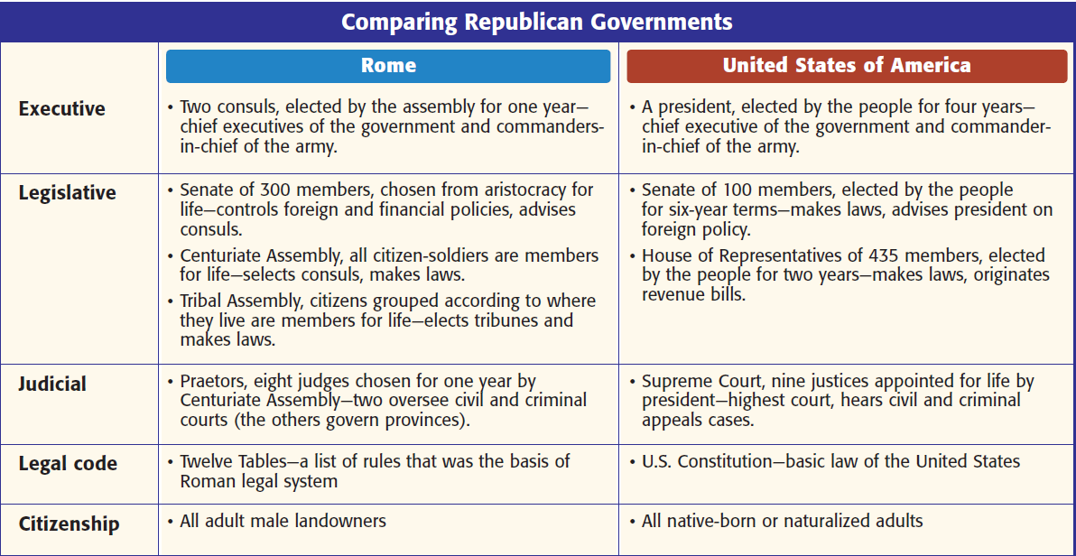

Roman Military
- Rome was protected by an advanced army that was divided into groups of 5,000 soldiers called ______________________________________
  - Each legion was divided into smaller groups of 80 men called a __________________________

