Petrarch & Renaissance Literature

Literature, like other Renaissance art forms, was changed by the rebirth of interest in classical ideas and the rise of humanism. During the Italian Renaissance, the topics that people wrote about changed. So did their style of writing and the language in which they wrote.

In medieval times, literature usually dealt with religious topics. Most writers used a formal, impersonal style. Most Italian writers wrote in Latin. Their work could be read only by a few highly educated people. In contrast, Renaissance writers were interested in individual experience and the world around them. Writing about secular, or non-religious, topics became more common. Writers used a more individual style, and they expressed thoughts and feelings about life. By the end of the Renaissance, most writers were writing in their own dialect instead of Latin. As a result, far more people could read their work.

The interest in learning during the Renaissance was spurred by humanism. This way of thinking sought to balance religious faith with an emphasis on individual dignity and an interest in nature and human society. Humanism first arose in Italy as a result of the renewed interest in classical culture. Many early humanists eagerly hunted for ancient Greek and Roman books, coins, and other artifacts that could help them learn about the classical world.

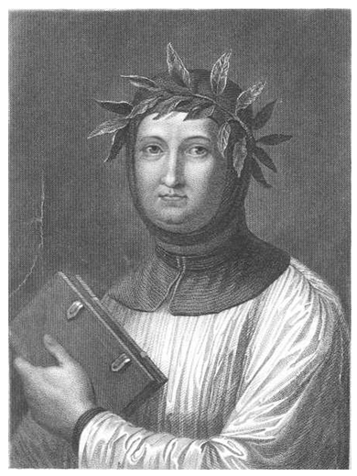
One of the first humanists was an Italian poet named Francesco Petrarch. Petrarch especially loved old books. He searched for them all over Europe and encouraged his friends to bring him any they found. Eventually, he created a large collection of ancient Latin and Greek writings, which he made available to other scholars. Petrarch is considered the founder of Italian Renaissance humanism.

“Five enemies of peace inhabit with us – avarice (greed), ambition, envy, anger, and pride; if these were to be banished, we should infallibly enjoy perpetual peace. “
—Petrarch
Dante Alighieri – Humanist Writer from Florence

Dante Alighieri, a native of Florence, was the first well-known writer to create literature in his native language. Dante wrote his long poem The Divine Comedy in the vernacular, or native speech, of Florence. Before his poem was published, people had thought that the local way of speaking wasn’t suitable for fine writing. But when the poem became highly celebrated, the language Dante used became the language of the Italian Renaissance. It became the language used for both everyday speech and fine writing.

Like other humanist art, The Divine Comedy highlights strong emotions and the experiences of individuals. Dante’s poem is a social commentary, too. It is filled with real people. The inhabitants of hell included people Dante disapproved of. People in heaven he admired.

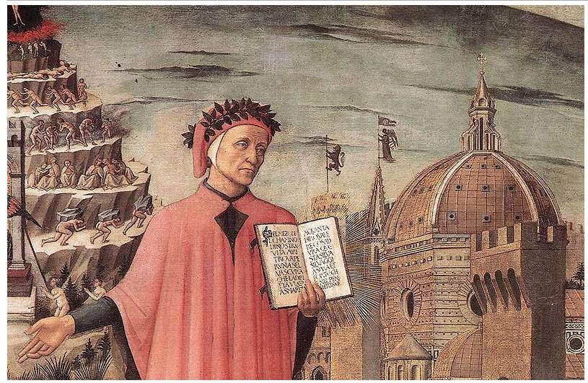
Dante’s work became a model for other Renaissance writers. He strongly influenced two important Florentine writers, Petrarch and Boccaccio. They described people’s lives with a new intensity of feeling and like Dante, they wrote in the vernacular, so their words touched many more people.

The Afterlife in Dante’s The Divine Comedy
Dante’s long poem, The Divine Comedy, describes an imaginary journey through three places Christians believed that souls went in the afterlife.

Inferno (Hell)
In the first part of the journey, Virgil, a poet of ancient Rome, acts as Dante’s guide through hell. In hell, Dante sees many lonely souls, among them a number of important people in Florence. He gives a description of their sins and the torturous punishments they receive.

Purgatorio (Purgatory)
In the second part of the journey, Virgil leads Dante through purgatory. In purgatory, people pay for their sins to try to get to heaven. It is harsh there, but the sorrow is not so deep, for there is hope of being saved.

Paradiso (Heaven)
In the third part of the journey, Beatrice, a woman Dante loved deeply but who died at an early age, acts as his guide. Beatrice leads him through heaven, where all sins are forgotten and everyone lives in peace with God.
Niccolo Machiavelli - Writer from Florence

Niccolo Machiavelli served in the government of Florence during a time of invasions and wars with other city-states. After he lost his government job, Machiavelli used his experience in politics to write a book about how politics and government really worked.

In his book The Prince, Machiavelli says that to be a successful ruler, a prince (government leader) must be willing to be feared rather than loved. Machiavelli suggests that it is acceptable for a ruler to use force to stay in power and to bring peace to the city-state. He advised rulers to make their states strong by doing what worked best, rather than by being good or moral. He said that they should even lie if it helped them to rule. In his view, the end, or purpose, justifies the means (the actions taken to achieve a certain purpose).

The Prince seems to contradict humanist ideals about people’s goodness. It’s cold realism shocked many readers. Yet in other ways the books shows the influence of humanist ideas. It was the product of one individual’s careful observation and thinking. It was concerned with how things really worked in the world. It also separated ideas about government from religion. In this respect, The Prince was a very modern book.

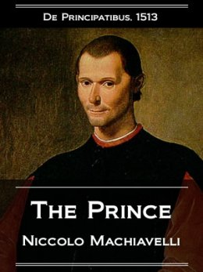
Quotation 1
A prince should have no other aim or thought, nor take up any other thing for his study, but war and its organization and discipline, for that is the only art that is necessary to one who commands.

Quotation 2
Thus, it is well to seem merciful, faithful, humane, sincere, religious, and also to be so; but you must have the mind so disposed that when it is merciful to be otherwise you may be able to change to the opposite qualities.

Quotation 3
In the actions of men, and especially of princes, from which there is no appeal, the end justifies the means.
Desiderius Erasmus – Humanist Writer from Holland

The ideas of humanists sometimes brought them into conflict with the Catholic Church. The church taught that laws were made by God and that those who broke them were sinful. It encourages people to follow its teachings without question in order to save their souls. For the church, life after death was more important than life on Earth. In contrast, humanists believed that people should use their minds to question everything. Most tried to balance religious faith and its emphasis on the afterlife with an active interest in daily life. Some directly challenged teachings that were dear to the church.

By the 1300s the church was beginning to lose some of its moral and religious standing. Many Catholics, including clergy and humanists, criticized the corruption and abuses that plagued the church. These reformers wanted to purify the church, not destroy it. By challenging the church’s practices and teachings, however, they helped pave the way for the dramatic changes that we will be studying in the Reformation.
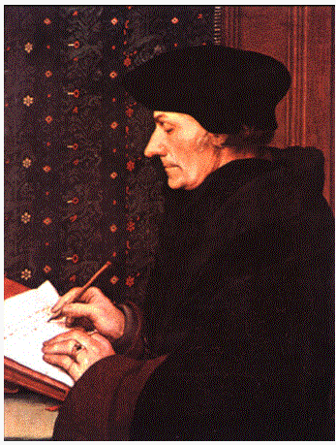
Desiderius Erasmus was a humanist from Holland. A priest and devoted Catholic, he was one of the most outspoken figures in the call for reform. In 1509, Erasmus published a book called The Praise of Folly. (Folly means “foolishness.”) The book was a sharply worded satire of society, including abuses by clergy and church leaders. Erasmus argued for a return to simple Christian goodness.

Erasmus wanted to reform the church from within. He helped, perhaps more than any other individual, to prepare Europe for the Reformation. His attacks on corruption in the church contributed to many people’s desire to leave the Catholic church.

Gutenberg and the Spread of the Renaissance

As you have learned, the Renaissance began in Italy. From there it spread to France, Germany, Holland, England and Spain. Renaissance ideas were spread through trade, travel and education. Italy was the gateway to Europe for much of the trade from Asia, Africa, and the Greek-speaking cities of the east. Traders moved through Italy to the rest of Europe, bringing a rich flow of new ideas along with their goods.

The spread of ideas was made even easier by the invention of the printing press. This machine presses inked type or plates onto paper to create many copies of a work. Recall from your study of China that the Chinese had learned to make paper and to print using wooden blocks. Gradually, knowledge of papermaking and examples of Chinese printing blocks reached Europe.

In about 1450, a German named Johannes Gutenberg dramatically improved on existing printing methods. He invented a printing press that used movable type – characters that could be rearranged and used over again on other printing jobs. Unlike the Chinese, who used wooden blocks for printing, Gutenberg cast his type in metal.

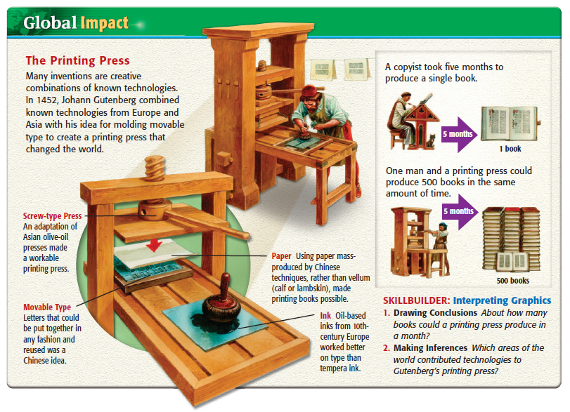
Before Gutenberg’s invention, most books were written and copied by hand. It could take four or five months to copy a 200-page break. The new press could produce 300 pages in a single day. As a result, books and short works called pamphlets could be made much more quickly and cheaply. The number of printers in Europe soon increased rapidly. People used printed matter to spread new ideas, discoveries, and inventions. And since printed material was more widely available, more people learned to read. The first book printed was the Bible, which spread rapidly throughout Europe.

CP World History (Unit 6, #4) Name ______________________________
Date ___________________ Pd ________
Humanist Writers and Renaissance Literature

Petrarch & Renaissance Literature:
Record at least three facts from this reading.

Briefly describe two ways in which Renaissance literature differed from medieval literature.

How is Petrarch an example of a humanist thinker and writer?

Dante & The Divine Comedy:
Record at least three facts from this reading.

How is Dante’s The Divine Comedy an example of humanist art?

With your partner, examine the three pictures. After reading the description of Dante’s The Divine Comedy, identify which image illustrates each place along Dante’s imaginary journey through the afterlife.

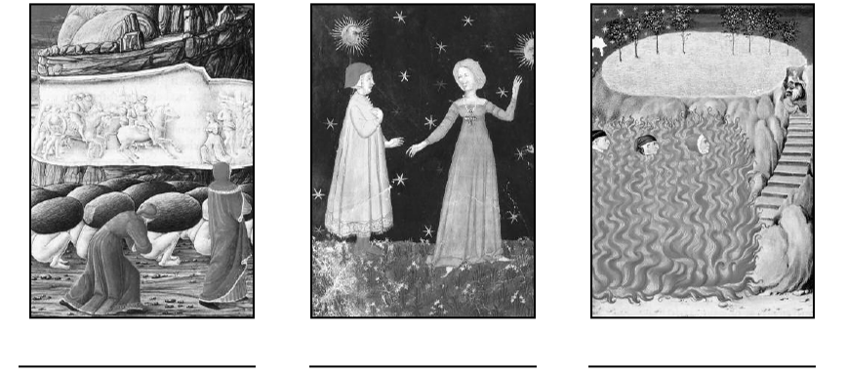
Machiavelli & The Prince:
Record at least three facts from this reading.

How is Machiavelli’s The Prince an example of humanist art?

Rewrite each quotation in your own words as if explaining to another student what Machiavelli meant. Then indicate whether you agree or disagree with his statement and why.
Quotation 1:

Quotation 2:

Quotation 3

Erasmus:
Record at least three facts from this reading.

How is Erasmus’ book The Praise of Folly an example of humanist art?

Who was Desiderius Erasmus and how did he help to prepare Europe for the Reformation?

Gutenberg & the Spread of the Renaissance:
Record at least three facts from this reading.

Gutenberg’s printing press revolutionized learning in Europe. What other invention that we have studied has had a similarly large impact? Why did you choose that invention over others?

What modern invention could you compare to Gutenberg’s printing press in the impact that it has had? Why?

