Byzantine Empire Guided Notes
What Happened to the Roman Empire by 500 A.D.?
- After the _________________________, the Roman Empire entered an era of decline
  - The Roman Empire had a series of __________________________ emperors
  - Romans had a large trade imbalance (they bought more than they produced)
  - As Rome grew more in debt, the __________________________ became weak & began using foreign mercenary soldiers
- The __________________________ Roman Empire continued to grow weak
  - Emperor __________________________ moved the Roman capital to Constantinople in the Eastern Roman Empire
  - Emperor Diocletian tried to save Rome by _____________________ the empire
- By 476, barbarians ___________________________________ the Western Roman Empire
- The Western Roman Empire fell into the Middle Ages (“Dark Ages”) from 500 to 1300 A.D
What happened in the Eastern Roman Empire?
- While the Western Roman Empire was in decline…
- the Eastern Roman Empire remained _______________________
- The Eastern Roman Empire became known as the ____________________________ Empire.
How did physical geography impact the Byzantine capital of Constantinople?
- Constantinople was a _________________________ trade city located between the Mediterranean & Black Seas
Byzantine Empire
- Citizens in the Byzantine Empire thought of themselves as Romans & they shared some similarities with the Roman Empire:
- The Byzantine Empire kept alive _____________________________________ culture
- Constantinople was a ____________________________ for learning where schools taught philosophy, medicine, Greek and Latin grammar, geometry
- Constantinople used Roman-style architecture such as arches & domes
- Byzantine cities had ____________________________ for trade & arenas to entertain citizens
  - One of the most impressive architectural buildings in the Byzantine Empire was a
Christian cathedral called the ______________________________________
- The official language was _________________________ but most Byzantines spoke ________________________
  - Because of its location close to _________________________, most Byzantines had converted to Christianity before those in the Western Roman Empire
- Both the Roman & Byzantine Empires were ruled by emperors who had _______________________ power over the empire
- ______________________was the most famous byzantine emperor
  - About 50 years after the fall of Rome, Byzantine Emperor Justinian came to power & began __________________________________ Roman territories
Justinian Code
- To oversee his new empire, Justinian ordered ______________________ experts to consolidate old Roman laws into a single law code
- The Justinian Code _________________________ as the legal basis for criminal justice, marriage, property, slavery, & women’s rights
- The law code became one of the most important legacies of the Byzantine Empire & served as the basis for laws for the next ________________ years
Justinian
- In addition to expanding the empire & creating a uniform set of laws, Emperor Justinian also began large building projects
- He ordered the construction of the _____________________________ to show the importance of the church
- He built hospitals, aqueducts, public baths, schools, & courts
Empress Theodora
- Justinian’s wife Theodora had a lot of power & influence in the Byzantine Empire:
  - She met with & wrote to ____________________ leaders
  - She ________________________ Justinian & helped him pass laws
  - She encouraged building of Christian cathedrals
Division of Christianity
- Because of the distance & lack of contact between Byzantine Empire & Western Europe, Christianity developed _______________________
- All Christians based their faith on Jesus & the Bible
- But they had different __________________________ to show their faith
Division of Christianity
- Christians were organized the same way:
  - Archbishops & bishops oversaw regions where Christianity was practiced
  - Priests led individual churches
- But, Christians in the East & West disagreed over ___________________________ of the Church
Christians in Western Europe:
- Believed that there should be a __________________ to oversee bishops & give authority to all Christians
- Christians in Western Europe accepted the ___________________________ of the Pope
Christians in Eastern Europe:
- Believed that the Byzantine _________________________ had authority over issues involving Christianity
- Byzantine emperors relied on a _______________________ to oversee the church, but the emperor had final authority
- Christians in the Byzantine Empire did not accept the authority of the Pope
One of the biggest controversies among Christians was the use of icons:
- _____________________ were religious images to help Christians in their prayers & worship
- Some Christians thought this was “___________________________”
- In 730, the Byzantine Emperor banned icons & many Christians rioted
- Emperor Leo III ordered the destruction of icons in the Byzantine Empire
  - Riots broke out between people who wanted icons & _______________________ (those who wanted to ban icons)
  - The Pope in Western Europe ______________________________ the use of icons & called the Byzantine Emperor a heretic (a believer of false ideas)
    - The Pope __________________________ the emperor (kicked him out of the church)
The Great Schism
- These disagreements led to deep divisions among Christians & the ________________ ____________________ (split) occurred in 1054:
- Christians in Western Europe became the ______________________________ Church
- Christians in Eastern Europe became the _________________________________ Church
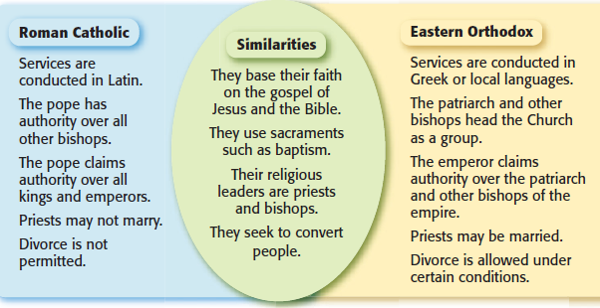
The Roman Catholics & Eastern Orthodox Christians practice differently

